

**Batch: A2 Name : Ashlesha Giri Roll No.:16010424040 Experiment No.:8**

**Aim:** Network Design using Simulation software

**Resources needed:**

# Cisco Packet Tracer

**Problem Statement :**

To design and implement a small network where two separate local area networks (LANs) can communicate with each other through a Cisco 1941 Router.

**Network Design :**

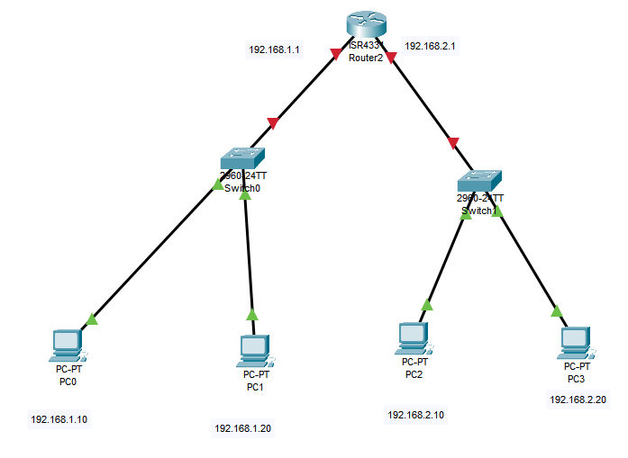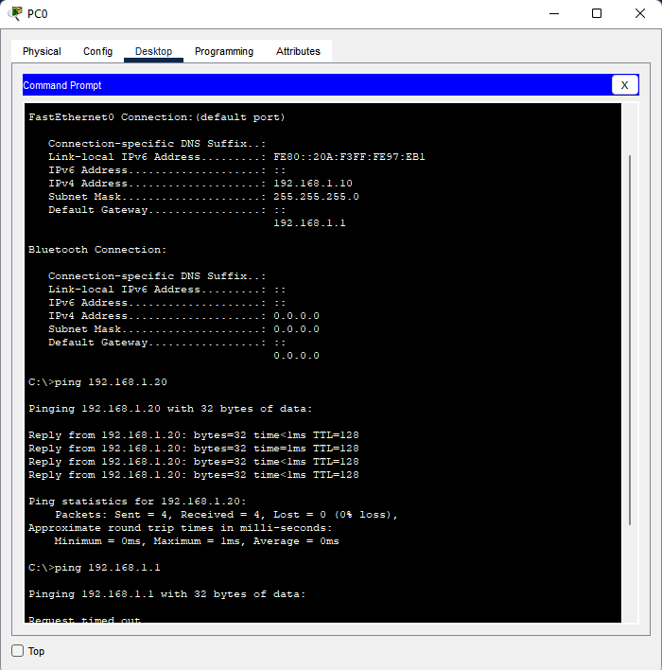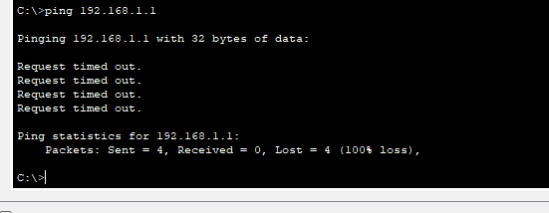

**Explanation:**

**This network connects two separate local networks (LANs) using a Cisco 1941 Router. Each LAN has a PC connected through a switch. The router has two interfaces, each connected to one of the switches, effectively linking the two LANs.**

* **PC1 belongs to the first network with the IP subnet 192.168.10.0/24.**
* **PC2 belongs to the second network with the IP subnet 192.168.20.0/24.**

**The router acts as a gateway between these networks, routing data so PCs on different LANs can communicate. Copper straight-through cables connect PCs to switches and switches to the router.**

**This setup is typical for small office networks needing simple routing between departments or segments.**

**Outcomes:**

**Conclusion:**

**Grade: AA / AB / BB / BC / CC / CD /DD**

**Signature of faculty in-charge with date**

**References:**

**Books/ Journals/ Websites:**